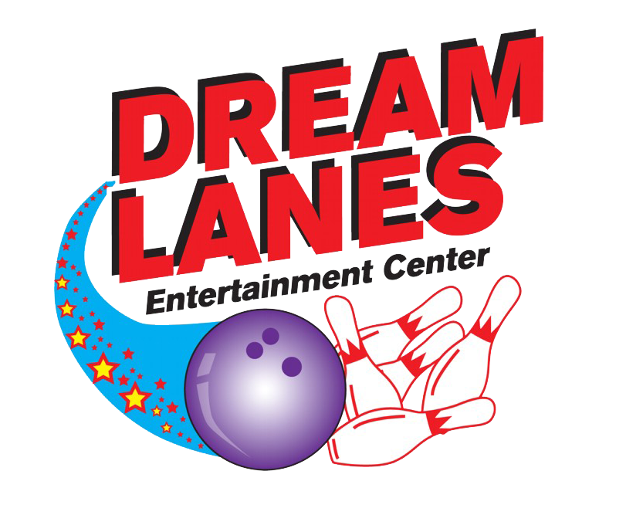
Celebrate Your Favorite Teams on the Big Screens!
Enjoy Drink &
Food Specials!
Take Advantage
of Game Time Special Pricing.
See our upcoming specials & Events at _______________ or (___)___-____
See latest in bowling fun at #______

